**Object Oriented Programming**

**DR.Love**

**Team - 9**

**Team Members**

* Guillermo Romero (Presentation Speaker)
* Jiwook Chung
* Ankush Mittal
* Ning Su

Do you feel lonely? Do you want to have a love affair? Dr Love is going to help you find your perfect person among all university students from Chung-Ang, whether you are looking for somebody to take care of you or somebody to pass a wild night with.

The only thing you have to do is telling him about you at first and then how your ideal person looks like and he will suggest you some good options.

**How does it work?**

Dr Love works with a database of people, each of one with different kinds of data: name, age, gender, height, major, etc. This database is formed by the people who use the program, since for using it you need to enter all your data first, which will be added to the database.

After entering the data, the user can look for other people inserting first his preferences. The preferences options are the age range (lower, similar, higher, don’t care), height range (lower, similar, higher, don’t care) and tags. Then, the list of people is displayed, excluding from the list the ones who are from the same gender as the user and the ones who are not in the ranges of age and height chosen and sorting the others putting in the first place the ones with the chosen tags.

All the information in the database is stored at the end of the program in a text file and read at the beginning of the program from it, so it can become permanent.

This is the basic prototype of the program to accomplish. After we are done with this we are also going a system of tags in order to add customized information in the database. The tags are created when the user enters his data and is stored also in a tag database. Then, when the user is entering his preferences, one more options is search by tag. At that point, all the tag will be displayed ordered by importance (number of people with the same tag), so you can select any of them to the search preferences.

The same user can use the program different times, so we implemented an option of ‘login in’ at the beginning through a user id/password system. The user id is unique for each user, whereas the user name can be repeated several times. Once the user has logged in, he will also be able to edit the data he previously entered before and then go to the search function again.

**Compilation and execution**

This project is made with Visual C++ 2010 and Windows Form. You can execute it from an .exe and, every time you execute it, if it is not previously there a text file whose name is “loversDatabase.txt” will be created in the same path as the file. This text file contains all the information of the users, so it should not be erased or edited without knowing how the program works with it.

**Global members:**

struct tag { //These are the tags stored in the database. They are sorted in order of importance

std::string name;

int amount; //Amount of times the tag appears among the users (importance)

};

enum t_gender {MALE, FEMALE};

enum t_preference {LOWER, SIMILAR, HIGHER, NONE}; //This is used for the preferences of the searching option (age and height)

void sort(std::vector<Lover>& vec, const std::string tag); //Function used for sorting by tags. It uses checkTagOrder (Lover), is used at the search function (LoversDatabase),and defined at ishtud.cpp

std::istream& operator >> (std::istream& is, t_gender& _gender); //For reading genders from file

bool operator<(tag t1, tag t2); //For sorting the tags in order of importance (amount < amount)

System::String^ toText(const std::string&); //Windows form conversion

System::String^ toText(const int); //Windows form conversion

Apart from the two main classes, a bunch of variable definitions and side functions can be also found in the header file. They don’t need much more explanation than the comments.

**class Lover: (the basic class)**

public:

Lover(){};

Lover(std::string _id, std::string _pass, std::string _name, std::string mess, std::string mail, t_gender _gender, int _age, int _height) : id(_id), password(_pass), name(_name), love_message(mess), email(mail), gender(_gender), age(_age), height(_height) {};

~Lover(){};

bool checkTagOrder (const Lover& a, const std::string tag); //True only when ‘a’ has the tag and the object calling doesn't. Used for sorting

std::vector<std::string> getTags() const { return tags; }; //Getter

void setTags(const std::vector<std::string>& _tags){ tags = _tags; }; //Setter

void addTag(const std::string tag){ tags.push_back(tag); }; //Push_back(tag)

std::string getId() const { return id; }; //Getters

std::string getPass() const { return password; };

std::string getName() const { return name; };

std::string getMess() const { return love_message; };

std::string getMail() const { return email; };

t_gender getGender() const { return gender; };

int getAge() const { return age; };

int getHeight() const { return height; };

void setId(const std::string _id) { id = _id; }; //Setters

void setPass(const std::string _pass){ password = _pass; };

void setName(const std::string _name) { name = _name; };

void setMess(const std::string mess){ love_message = mess; };

void setMail(const std::string _email){ email = _email; };

void setGender(const t_gender _gender) { gender = _gender;};

void setAge(const int _age){ age = _age; };

void setHeight(const int _height){ height = _height; };

friend bool operator==(const Lover&, const Lover&);

private:

std::string id;

std::string password;

std::string name;

std::string love_message;

std::string email;

t_gender gender; //MALE, FEMALE

int age;

int height; //cm

std::vector<std::string> tags;

This is Lover, the basic class. Each Lover represents one of the users who have been registered in the program. It doesn’t have much more apart from the setter and the getters, it is a storage class. It is important to explain what the tags are. They are small pieces of information that are customized for every user, so they can give more valuable personal information, like sports you like, your major, kind of movies, hobbies or the color of your hair. They can be used for sorting the results according to certain tags.

**class LoversDatabase**  (database class, main class)

public:

void readFile(); //Translates the information on loversDatabase.txt into users and stores it in the database. Called only at the beginning of the program

void writeFile(const Lover&); //Registers a user at the end of the loversDatabase.txt file. For doing that, it translate the information of the user into strings which are then written in the file. Each line represents a different field. Tags are separated by spaces and their spaces are substituted by _. Users are separated by #.

void editFile(const Lover&); //Erases the data from an existing user and writes it again at the end of the program with the updated information

void readTags(); //Reads from the database all the tags and add them to the tags system, counting also the times each of them appears. Called at the beginning/after new user

void insertUser(const Lover& lover); //Adds a new user at the database and the text file or edits a preexistent user and edits the file with the new information

bool checkUser(const std::string id, const std::string pass); //When logging in, checks if the user id and password match, in which case returns true and the user passes to be the current user

bool checkUser(const std::string id, int& pos); //Checks that that user's id exists already, in which case returns true and his position at the vector

std::vector<Lover> search(t_preference p_age, t_preference p_height, std:: vector<std::string> tags); //Return results according to user's preferences. Tags are not exclusive for searching, but they play a role in the order of potential lovers appearance

std::vector<tag> getTags() const { return tags; }; //Getters

Lover getCurrent() const{ return currentuser; };

private:

std::vector<Lover> lovers;

std::vector<tag> tags;

Lover currentuser;

This is the main class, which manipulates all the data and executes the main functions of the program. It is in charge of adding new users, editing existing ones, storing the data into the text file to make it permanent, update the tags, given information of the users and searching according to certain given parameters. It is the core of our program.

**Implementation details:**

**Lover.cpp**

bool Lover::checkTagOrder (const Lover& a, const std::string tag){

bool tt = false;

bool ta = false;

for(unsigned int i=0;i<tags.size();i++){ if(tag == tags[i]){ tt = true; };}; //this has the tag

for(unsigned int i=0;i<a.tags.size();i++){ if(tag == a.tags[i]){ ta = true; };}; //a has the tag

if(ta == true && tt == false){ return true; };

//a has the tag and this does not: a is considered to be before this

return false;

};

**CheckTagOrder** goes through all the tags from two different users and checks if a certain tag is in one user and not the other, in which case returns true so they can be sorted properly.

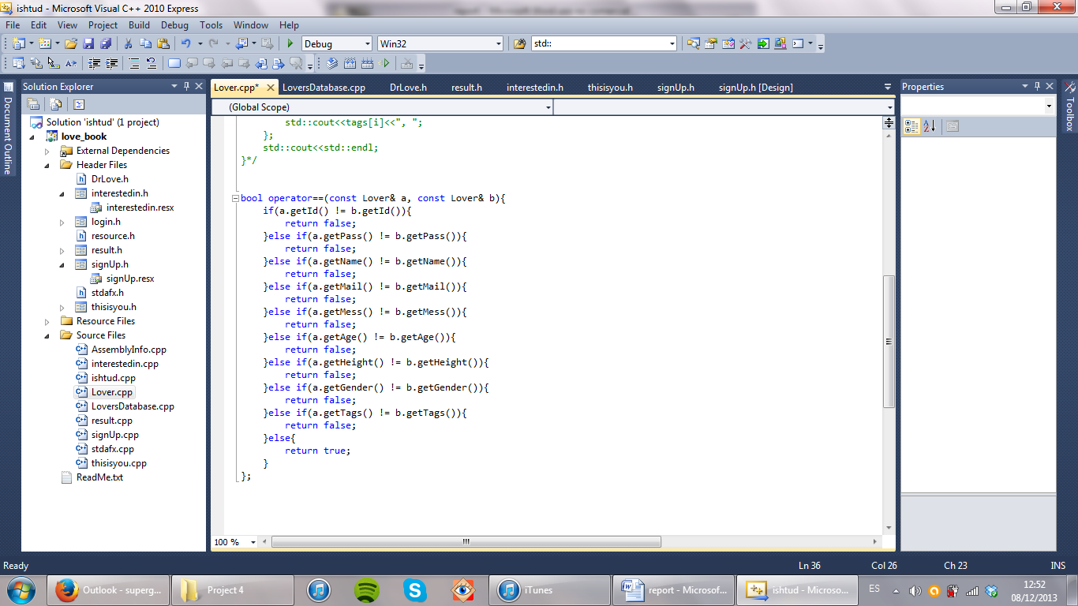

**Operator ==** uses a one to one equality at every field of each user.

**LoversDatabase.cpp**

**readFile() function:** uses the ‘iostream’ to read data from “loversDatabase.txt”. For doing that, it always follows the same order, being each line a different variable. When the program gets a #, all the user has been recollected, so a new user is created with this information. Tags are stored in the same line, separated by spaces and spaces substituted with commas, so when reading it has to translate this into a vector of strings.

void LoversDatabase::readFile(){ //Translate the information on Lovers.txt into use ifstream ifs("loverDatabase.txt"); //and stores it in lovers. Called at the beginning

if(!ifs.fail() || !ifs.eof()){

string id, pwd, name, mess, mail;

t_gender gender;

int age, height;

string tagstring, line;

unsigned int i = 0;

while(getline(ifs, line)){

switch (i++){

case 0:

id = line;

break;

case 1:

pwd = line;

break;

case 2:

name = line;

break;

case 3:

mess = line;

break;

case 4:

mail = line;

break;

case 5:

stringstream(line)>>gender;

break;

case 6:

stringstream(line)>>age;

break;

case 7:

stringstream(line)>>height;

break;

case 8:

tagstring = line;

break;

case 9:

if(line=="#"){

Lover temp(id,pwd,name,mess,mail,gender,age,height);

if(tagstring != "null"){

string temptag;

stringstream ss;

ss<<tagstring;

while(ss>>temptag){

for(unsigned int j=0; j<temptag.size(); j++){

if(temptag[j]=='_'){ temptag[j]=' '; }

}

temp.addTag(temptag);

};

};

lovers.push_back(temp);

}else{

exit(1); //The structure is messed up

}

i = 0;

break;

};

}

ifs.close();

}

};

**writeFile() function :** does the opposite than *readFile()*, but only with one user and at the end of the text file. It also has to reconvert tags to a single string with tags separated by spaces and spaces substituted by _.

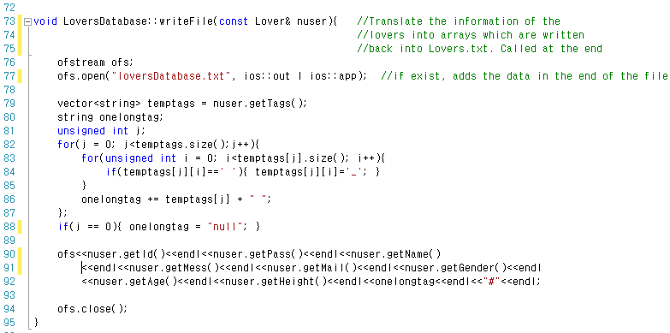

**editFile() function :** this function first copies all the data to a tempFile.txt, except from the data from the user, which is added after that at the end of the file with the updated information once the old file has been deleted and tempFile.txt renamed.

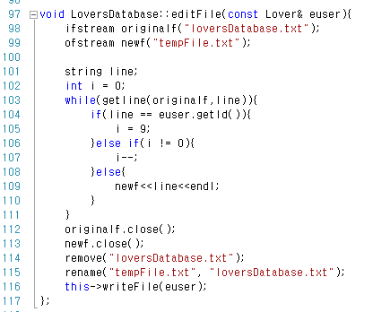

**readTags() function :** goes through all the users adding the new tags and increasing the number of the existing ones. At the end, the tags are ordered by importance (number of times appearing). The function is called at the beginning of the program and after a user is added or edited.

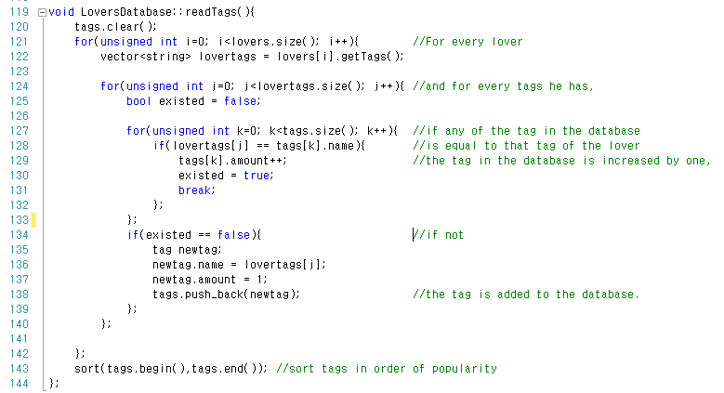

**insertUser() function :** first, checks if the user exists, in which case it means that is going to be edited, what is done in both the text file and the database. If he didn’t exist before he is created and added to both the database and text file.

void LoversDatabase::insertUser(const Lover& lover){

int i;

if(checkUser(lover.getId(), i)){

lovers[i] = lover;

this->editFile(lover);

}else{

lovers.push_back(lover);

this->writeFile(lover);

}

currentuser = lover;

this->readTags();

};

**checkUser() function :** this function has two different sets of arguments. In the first version, it checks if the user with the id exists and the password is the correct one, in which case it returns true and states that that user is using the program. The second version is used for getting the position of a user in the vector of the database. It can also be used for checking if that id exists already, since they cannot be repeated.

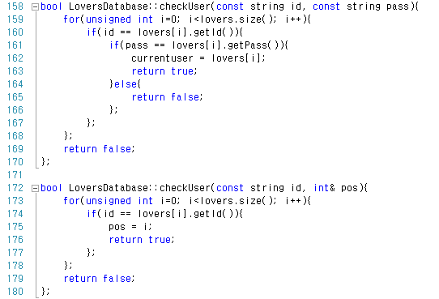

**search() function:** this is the function which matches the current user with other ideal users according to the preferences stated as arguments. For doing that, it goes through the database taking only the users from the other gender who suit the preferences stated by the users. Similar age is considered to be plus minus one year and similar height plus minus five centimeters. After that, the users who have the tags in the input argument are sorted so they will appear first.

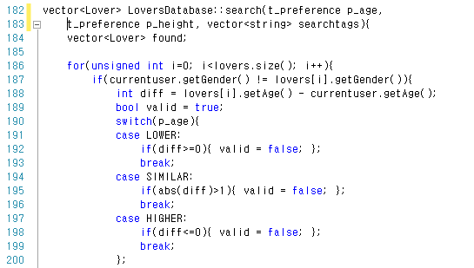

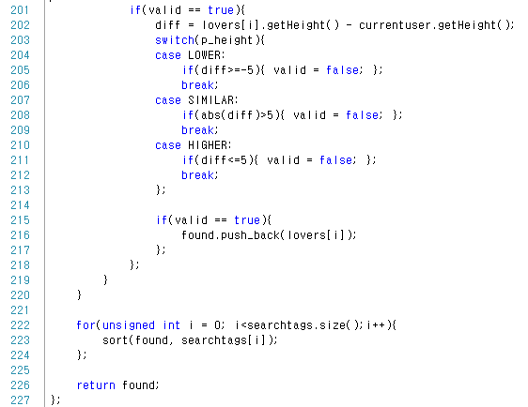

**Encryption system:** we also implemented a small encryption system to preserve the privacy of the users and for preventing people from stealing other people’s password. The decryption occurs at the beginning, when the file is read:

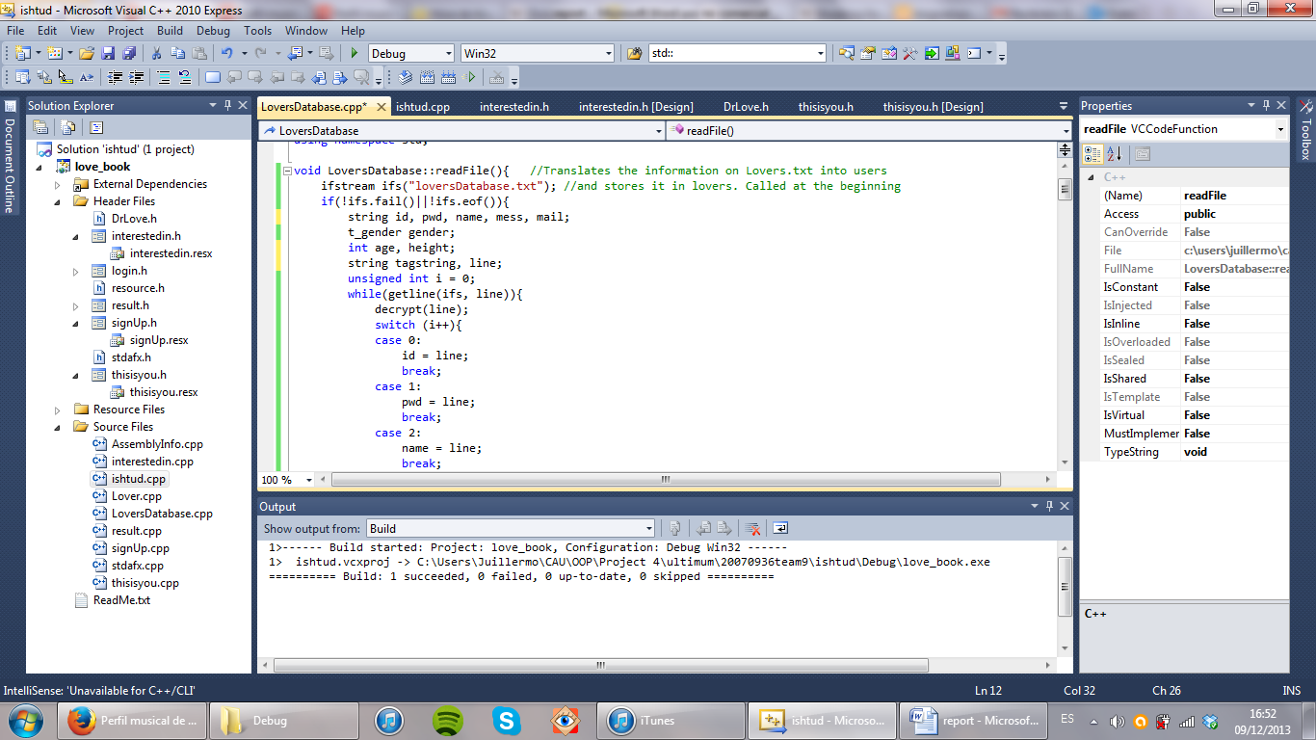

Every time a user is inserted in the text file he is encrypted first. Encryption also occurs when editing the file.

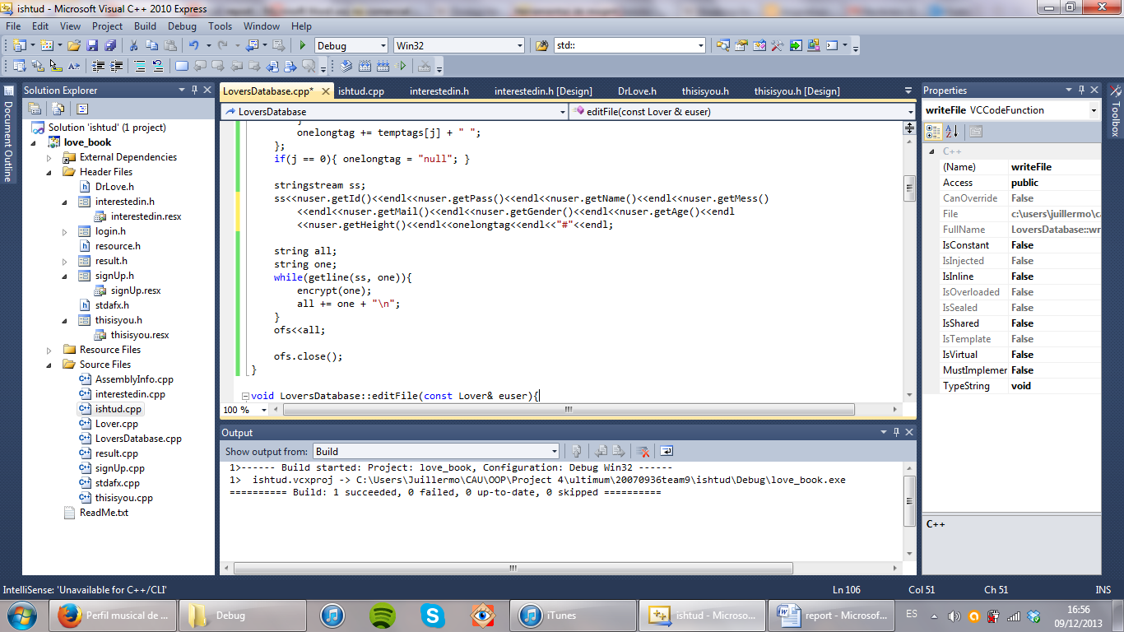

The encryption is not really secure since it can probably be easily cracked by decryption programs. However, it is good for preventing anybody just open the file and get the information. For encrypting the file, each character is added a number from -3 to 5 in sequence. For decrypting, the opposite operation is carried out.

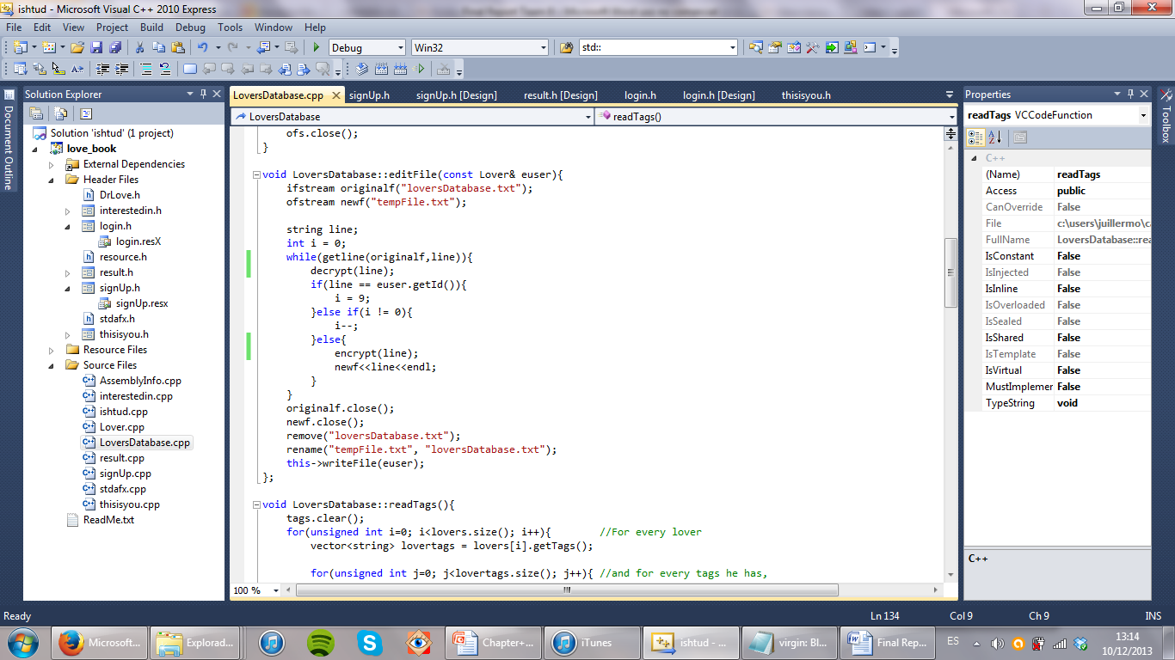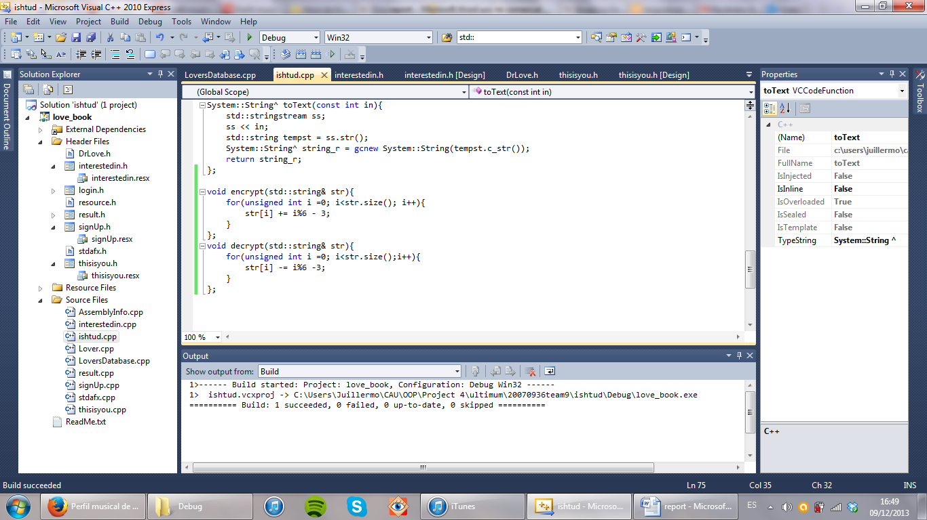

**The interface**

For giving to our program a better look than MSDOS we decided to implement it with Windows Form. With this, the user will interact with the programs using the buttons and text boxes that are spread in the different windows. I will explain every window and how we implemented our database there.

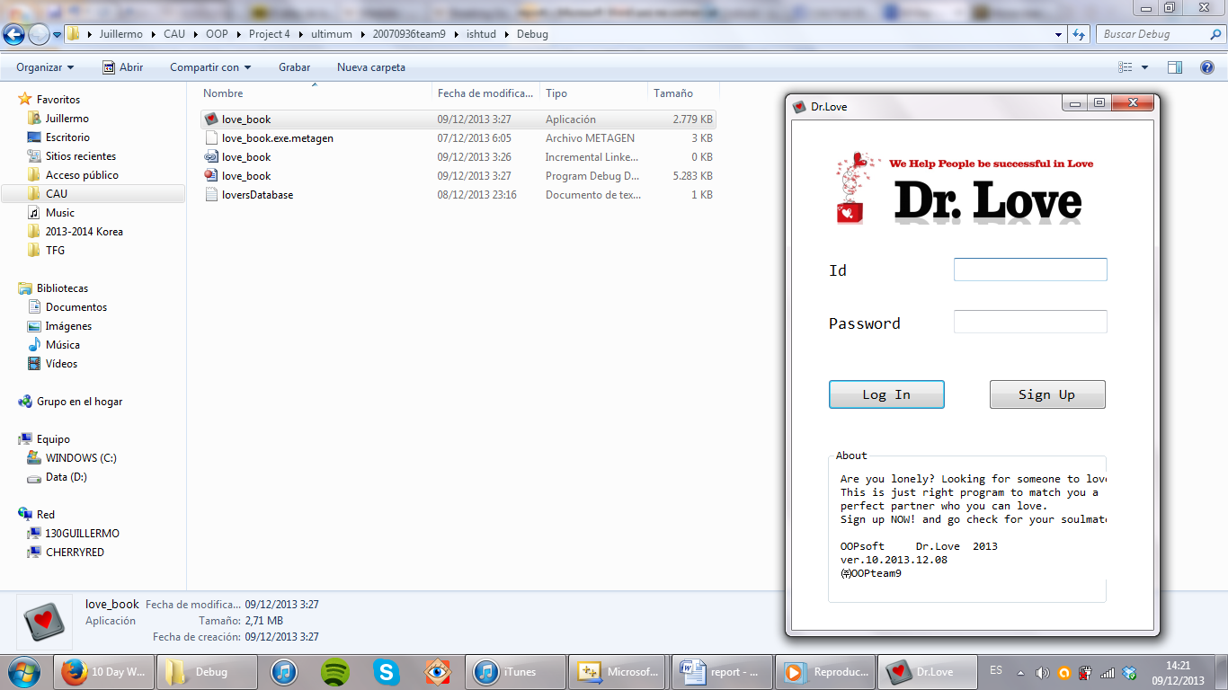

**login.h:** This is the very first windowthe program. There are two boxes for the users who log in, a log in button and a sign up button. We created for this and all the others forms a second constructor with a pointer to the database, so all its functions can be used inside.

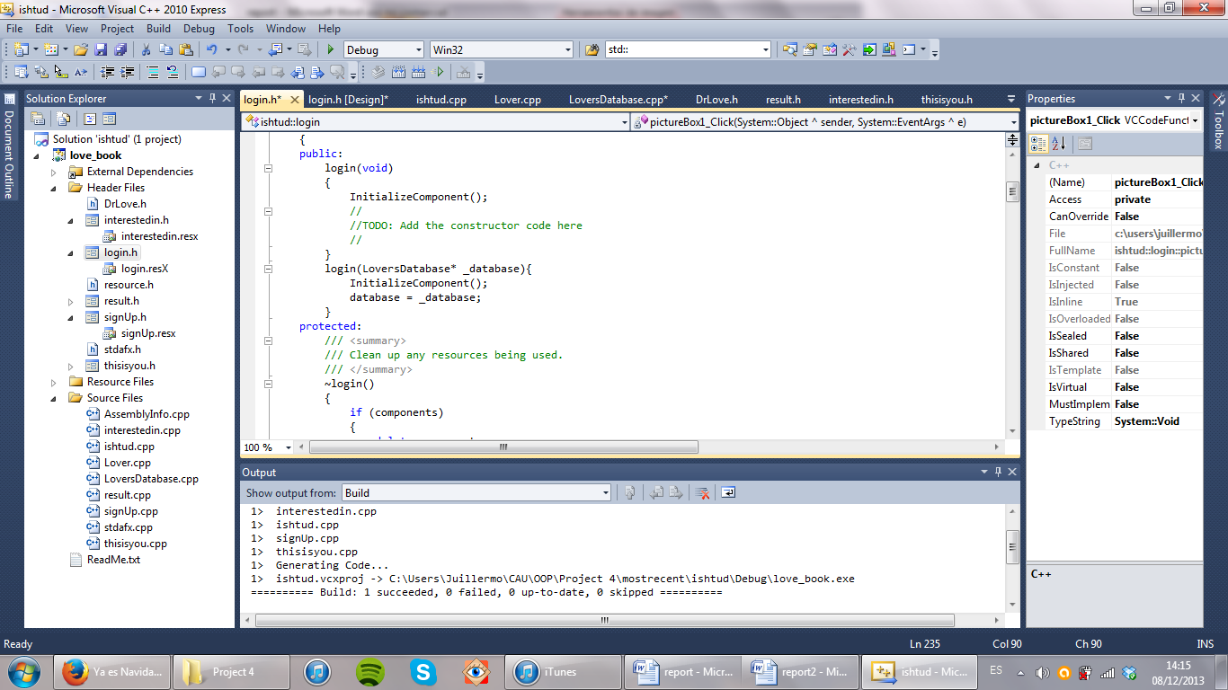

**LOG IN button:** first, it translates the string in the text boxes to standard strings. Then, it checks if the id and password are correct, in which chase the window is closed and the next windows appear: thisisyou, a window with the info of the user. If id and password are not correct an error message appears.

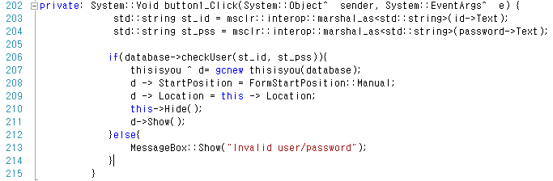

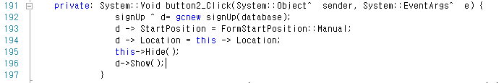**SIGN UP button:** goes to the next window, signup, in which the new user will input his data.

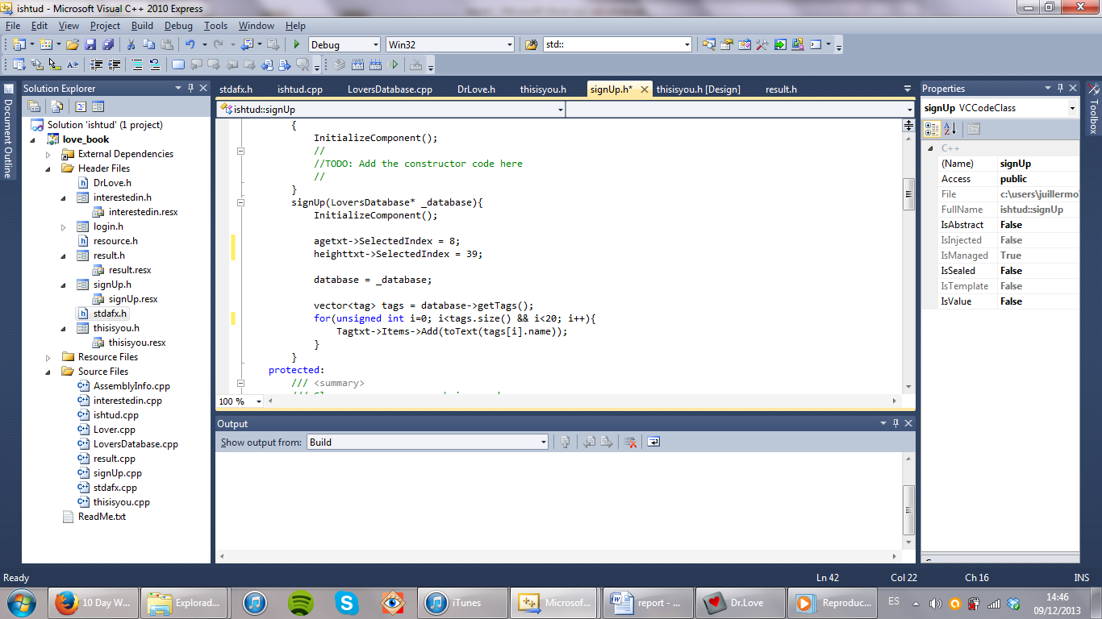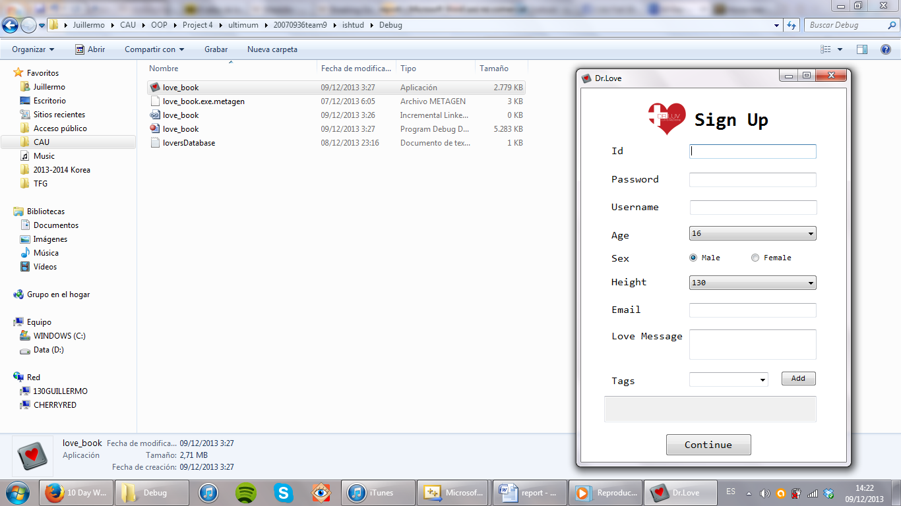**Signup.h:** This window has different text boxes for getting the inputs from the user. Some of them are plain text boxes, there are also two combo boxes which a set of possible options (age 16 – 50 and height 130 – 220), a radio box for the gender and the tags system in the end. This time the constructor has something more. The SelectedIndex statements make sure that age are height have default values, so their values at the end cannot be blank. The for loop at the end initializes the options that appear in the combo box for the tags. The user can see previous tags entered by other people, so he can get some ideas and reuse the tags. If not, he can always input his own tags.

**ADD button:** when the user clicks this button, the text in the tag combo box is read and then the function checks if it is equal to any of the previous tags. For doing, all the text in the tags box must be first read and processed into different single tags without commas or spaces. This is done through a stringstream which separates the words, a for loop which erases the commas and a system of flags for separating the tags one from the other (tags can have multiple words).

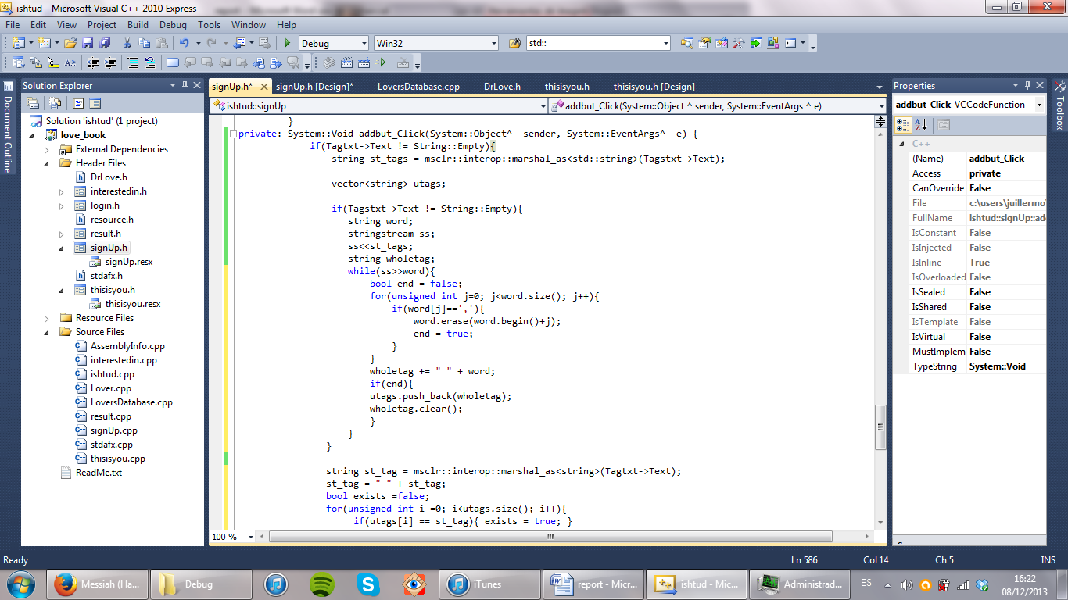

Then, the text from the input tag is translated into the same format as the rest of the tags and a comparison is made. If it is a new tag, it is added to the end of the vector of tags and everything is then written again in the tags box.

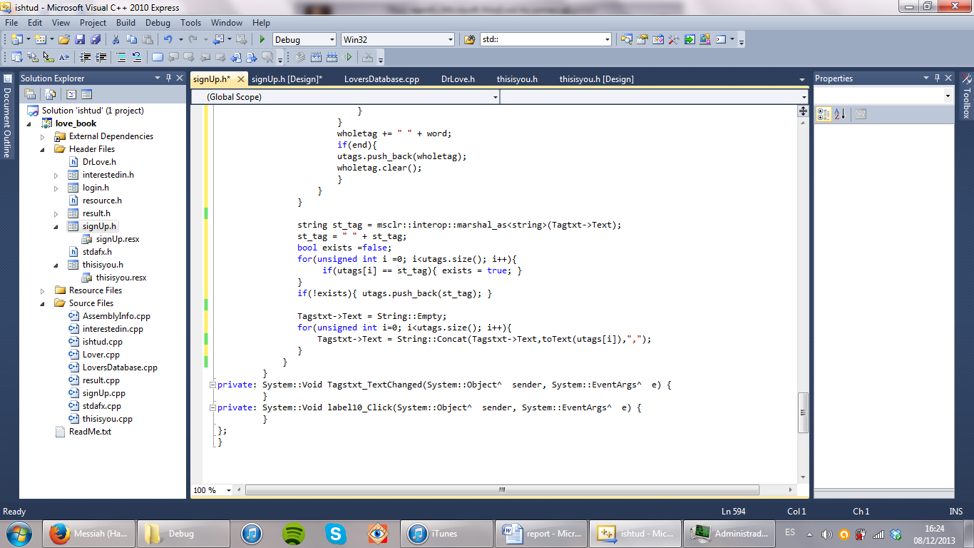

**CONTINUE button:** when this button is clicked, the first thing is checked is whether there is any blank box, in which case an error message appears. If not, the program checks whether the user exists already, which also displays an error message. Providing these two are satisfied the algorithms for storing the user start. The first thing to do is translating the data into the variables of the Lover. Once this is done, a new user is created.

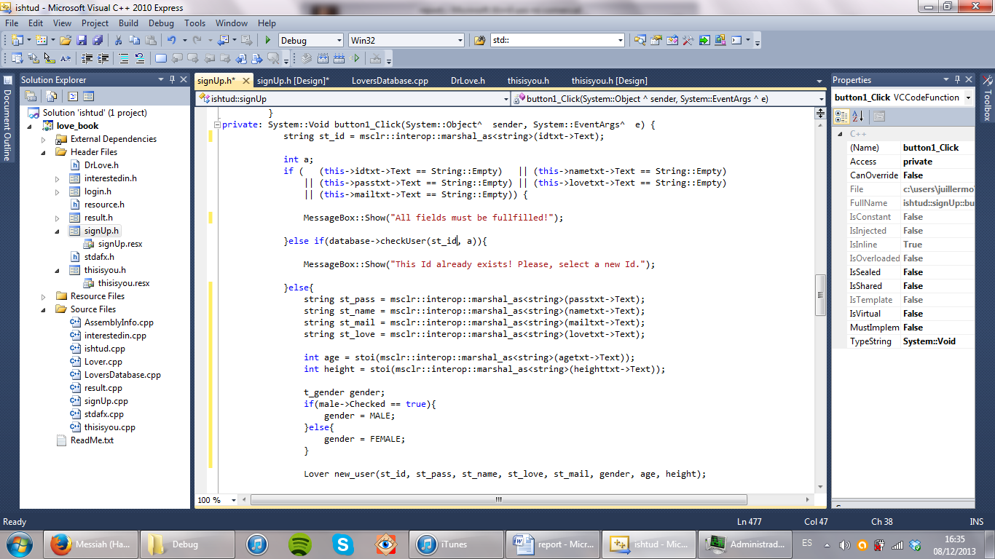

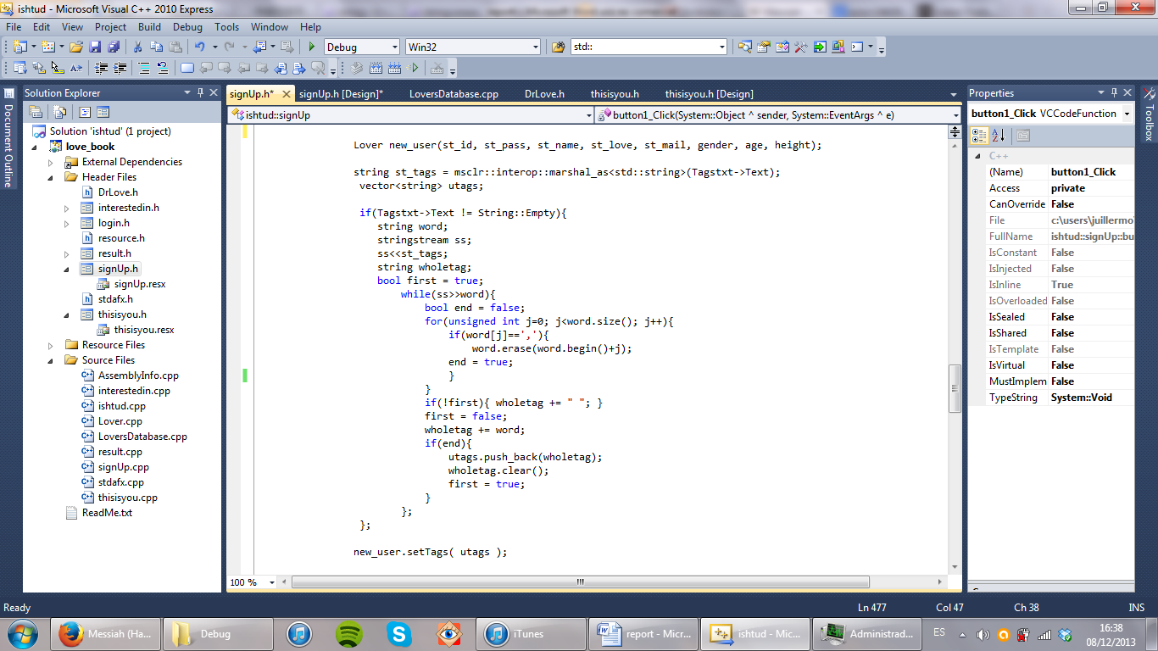Next thing to do is adding the tags. For doing this, the same method as in the ADD button is used for translating the tags box into a vector of strings. Then, the setter for tags is used and the new user is inserted in the database. Finally, the window is hidden and next form appears.

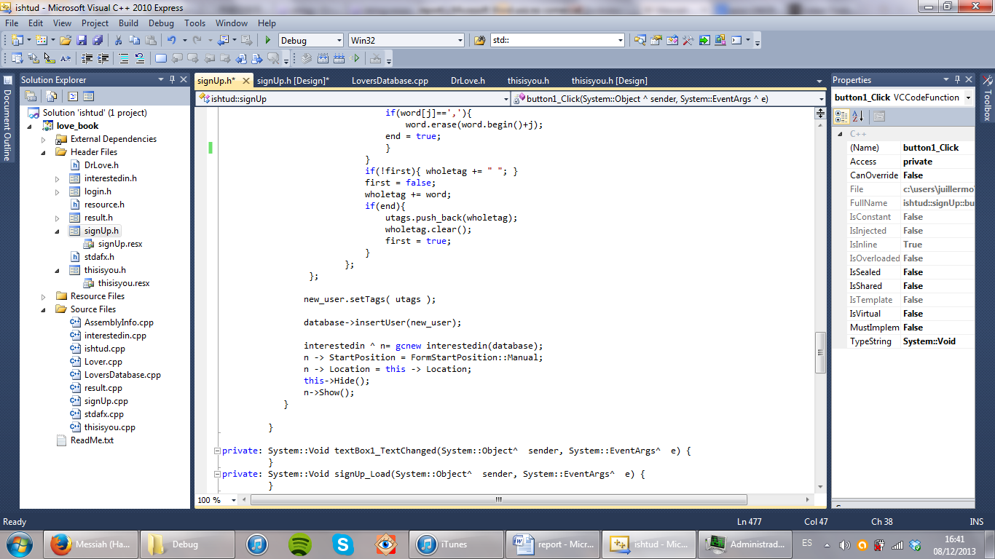

**Interested.h:** this window is where the user can choose preferences for the search of matched lovers. The restrictions are mainly two: age and height ranges, both taken by two independent groups of radio buttons. The tags system is exactly the same as the one used in signup.h, except that there is no option of entering new tags at this point. The constructor is also almost the same as in the previous form.

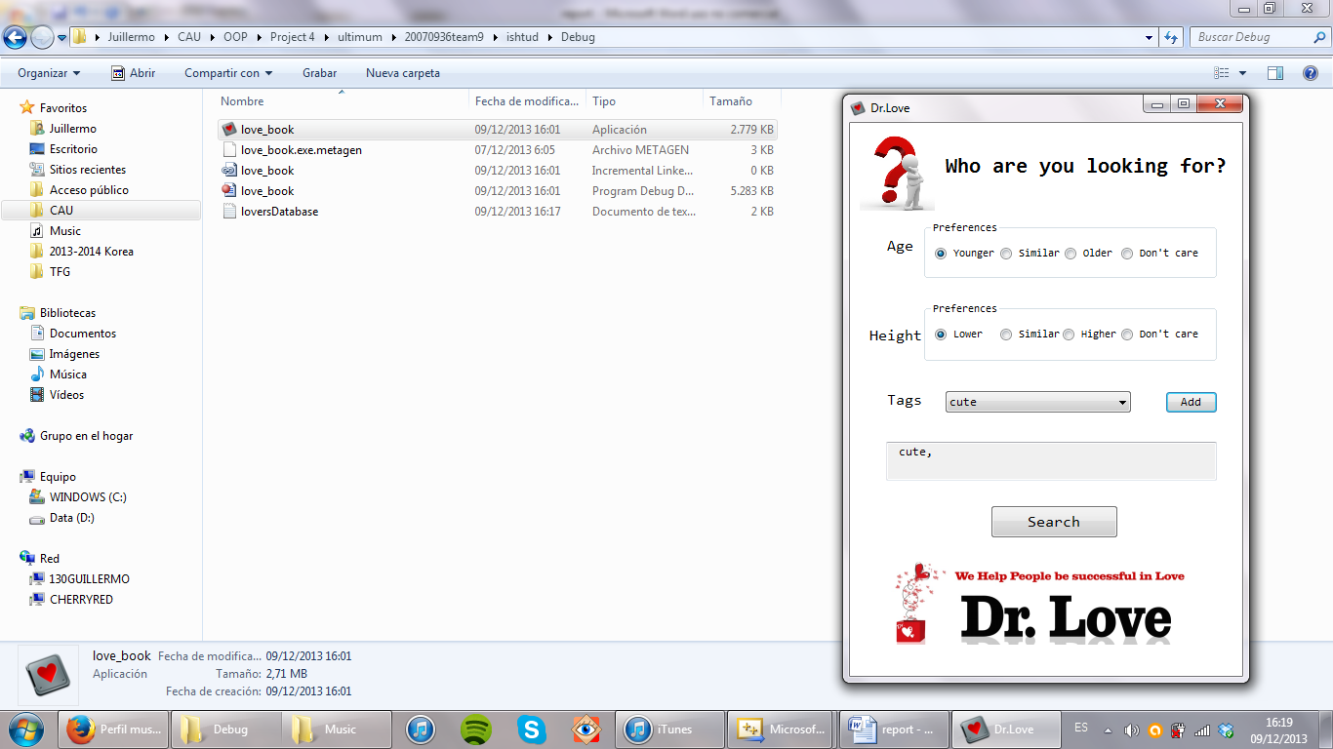

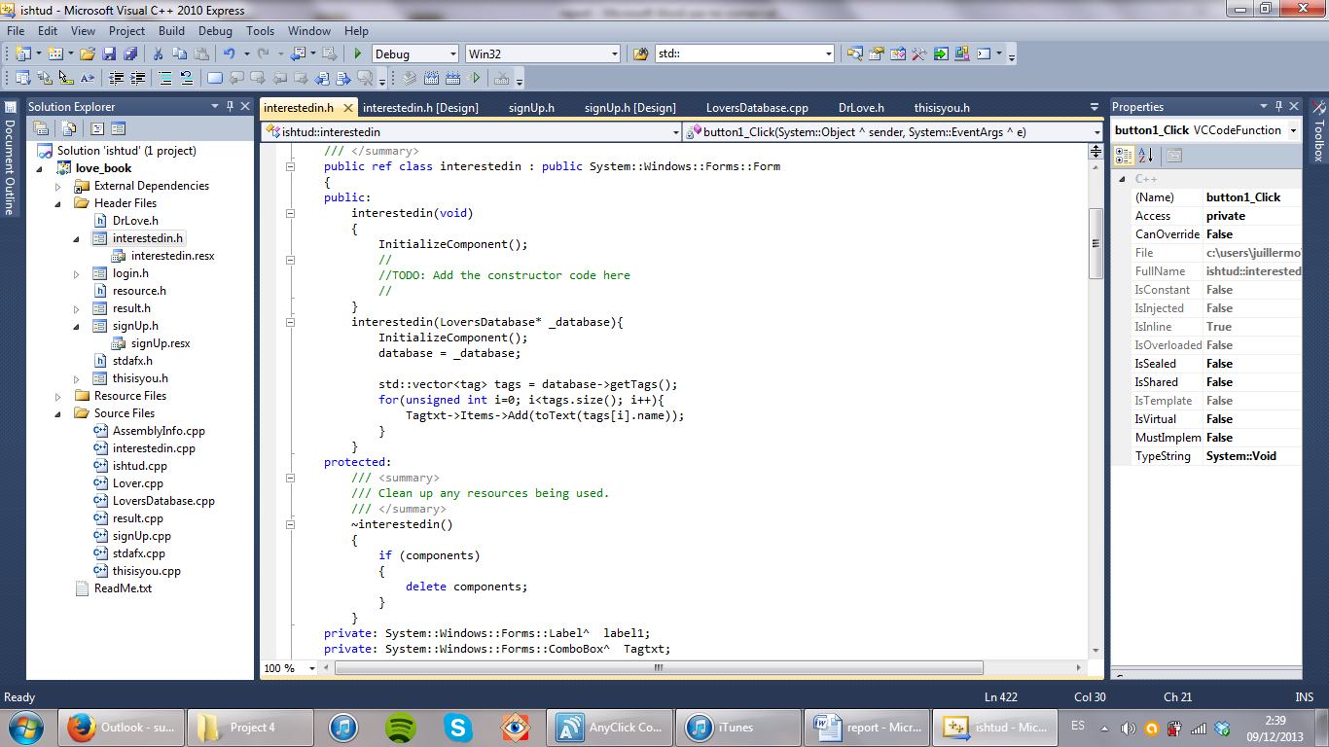

**SEARCH button:** when the search button is clicked, the preferences are read from the radio buttons with a couple of if else statements. Then, they and the string containing the tags are carried to the next form, result.h.

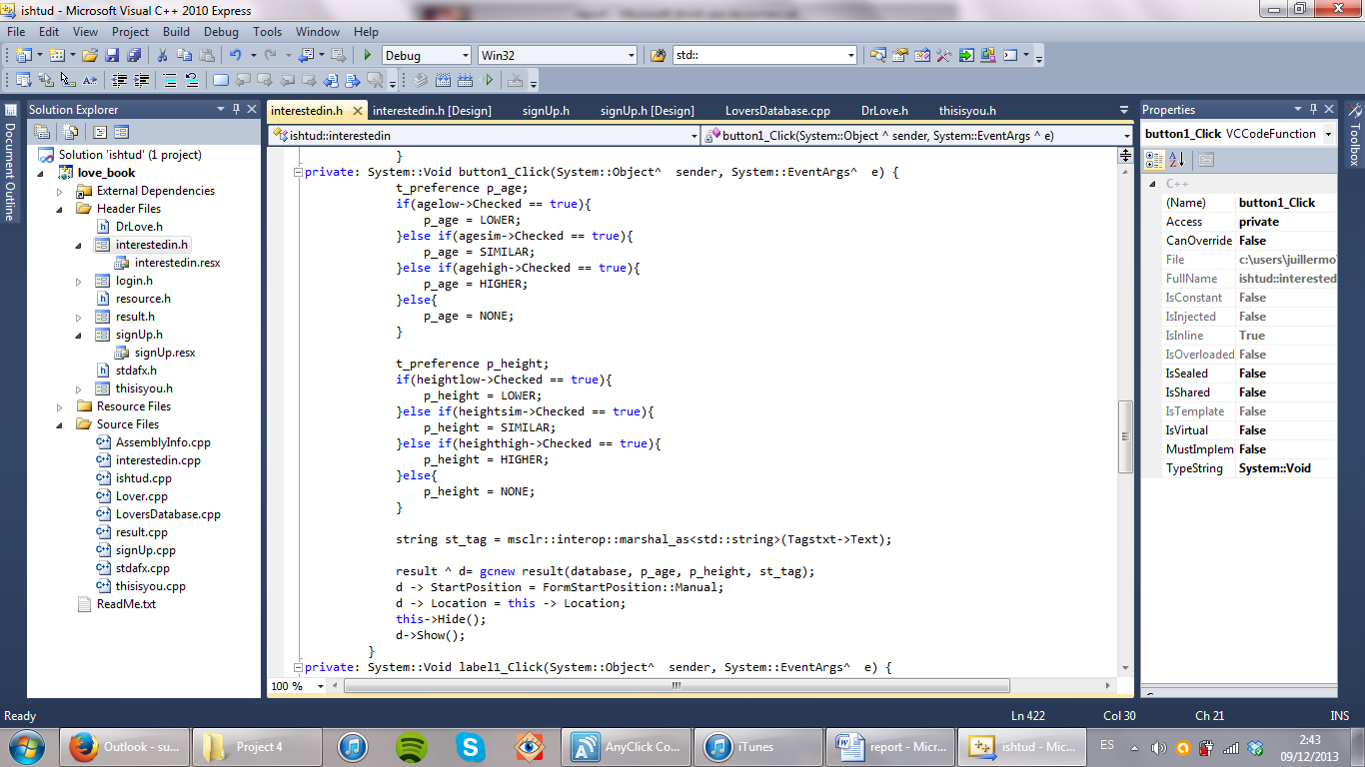

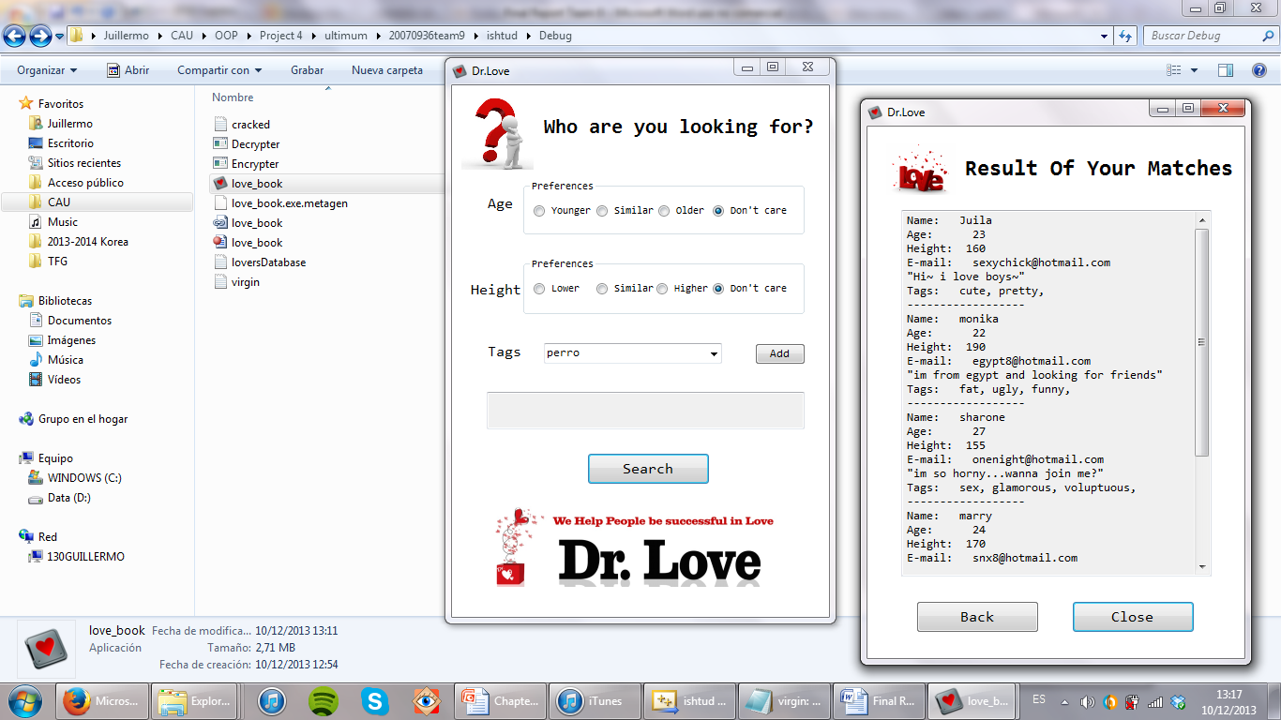**Result.h:** The last window of our program shows the results of the search requested by the user. There is no interaction possible in it, just a big output text with scroll and a button for closing the application. These results are computed at the beginning of the form, with its constructor. For doing that, the first thing to be done is the translation of the long string into real multiple tags with the same system as used in signup.h. Then, the search function is called from the database.

While the BACK button takes you back to a new search, the close button closes the application

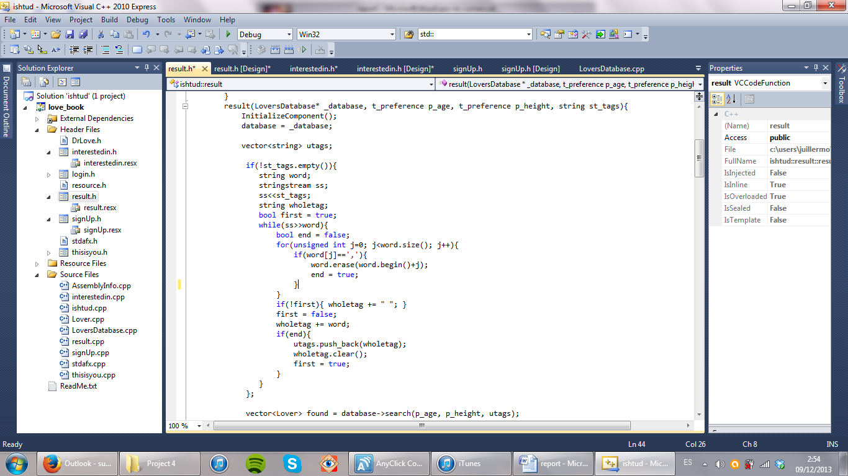

Once we have the users, we have to translate them into text to be displayed at the text box, so all the info from each user is condensed in one single sentence and the sentences are concated and displayed at the big text box. Returns are introduced by “\r\n” and lines of dashes separate the different users.

Finally, the CLOSE button closes the application:

private: System::Void button1_Click(System::Object^ sender, System::EventArgs^ e) {

Application::Exit();

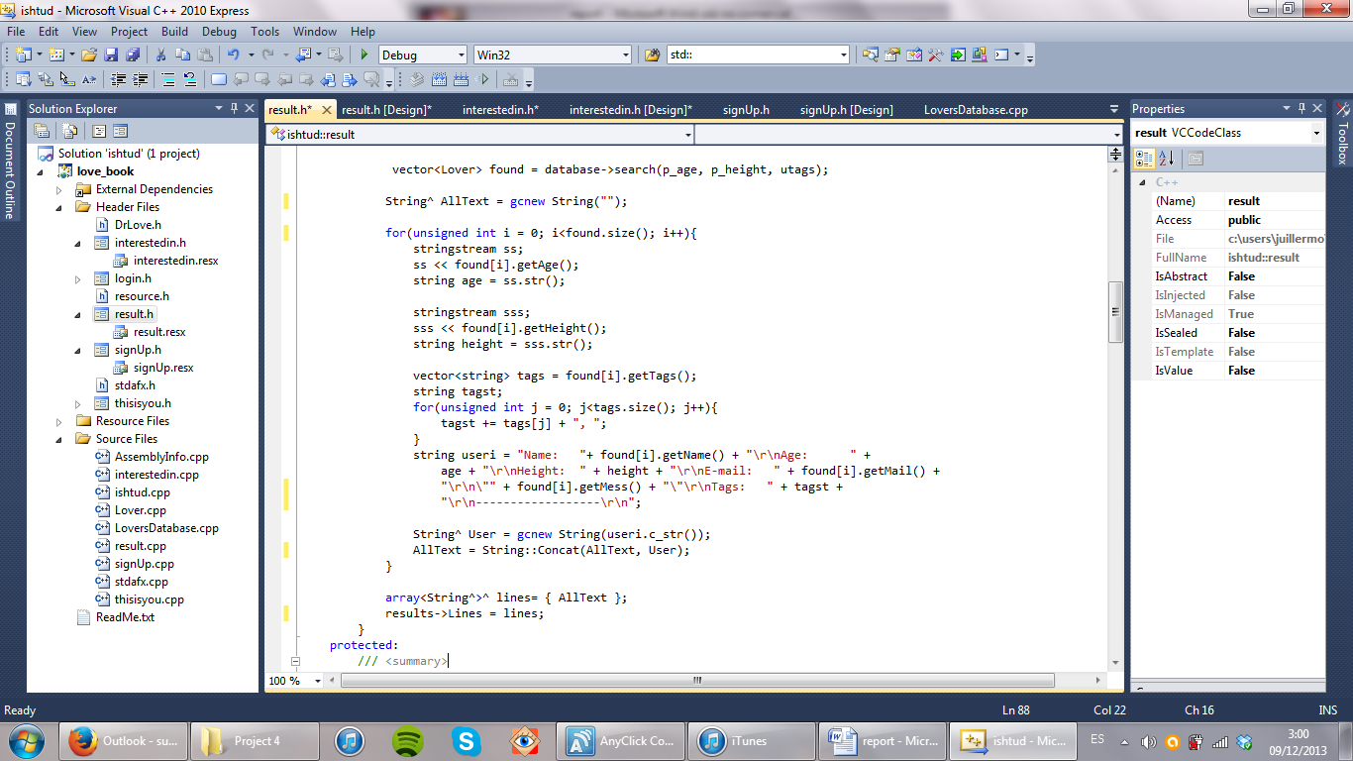}

**thisisyou.h:** This form shows the user the info they have in the database, allowing them to change any of the fields. The only difference that it has compared to the signup.h form is that Id cannot be changed and the gender doesn’t appear.

At the constructor, all the info from the user must be read so it can be displayed at the window. The tags from the database are also charged into the tag input text. The code behind the buttons are practically the same, except for minor changes.

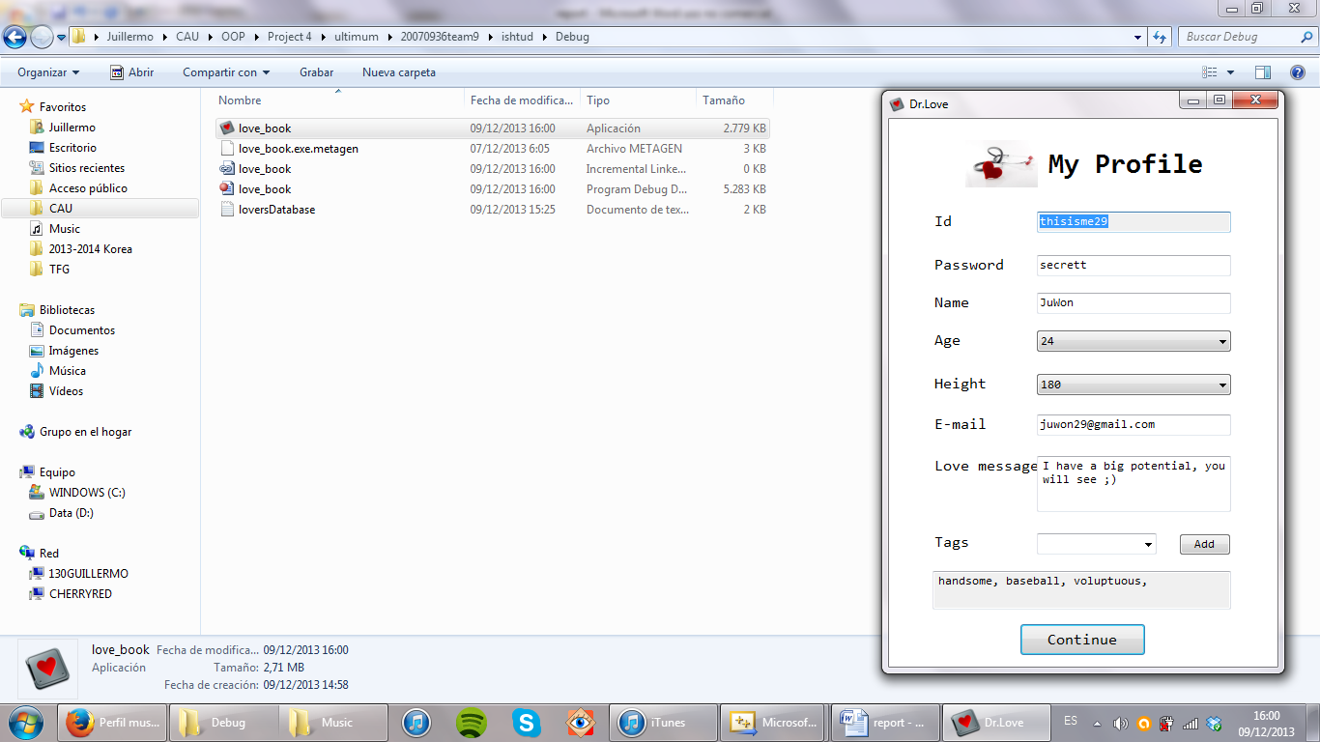

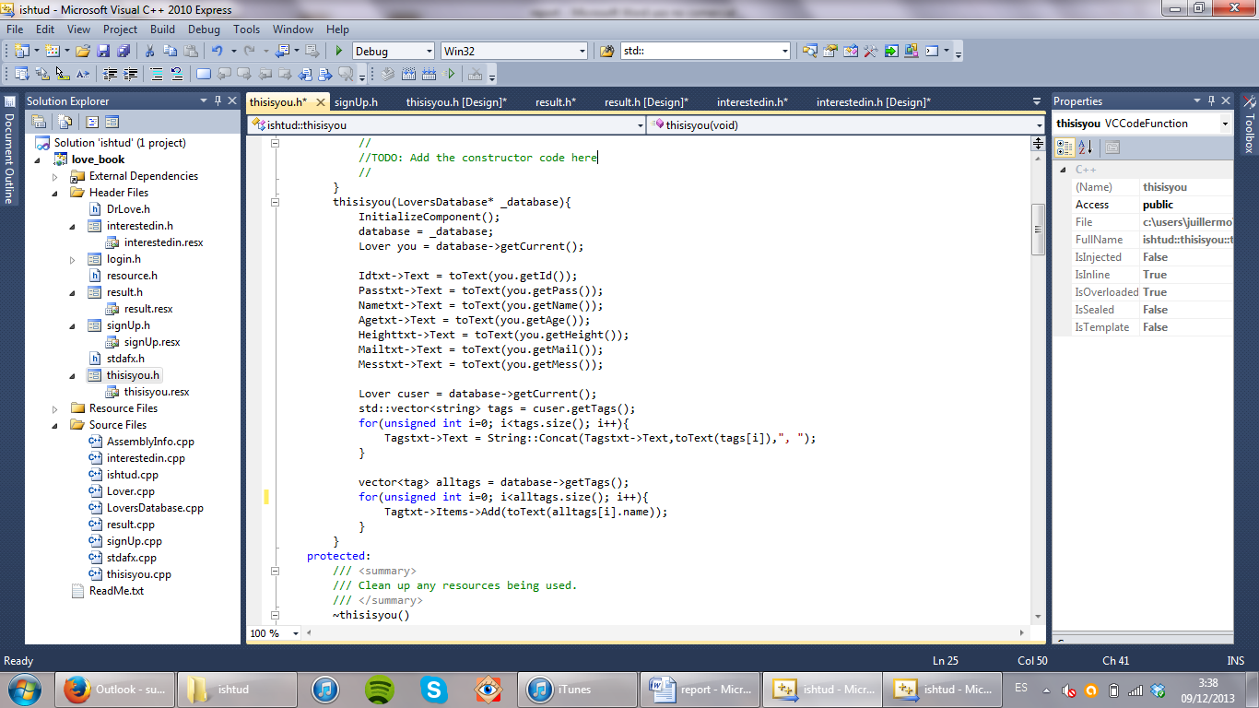

**Ishtud.cpp (the main file)**

At the beginning of the program the text file is read and the tags are read from the database. Then, the first window, “login.h”, appears.

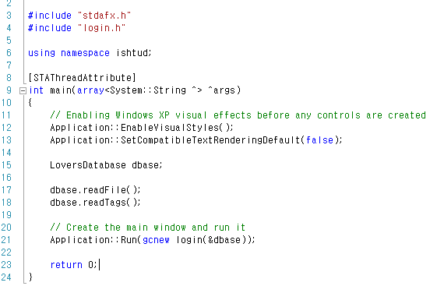

**Execution results:**

First window and sign up window (after pressing the SIGN UP button). We have put a sample user. Age starts by default at 25and height at 170. If the user clicks at the arrow, he can chose from a list with the first 20 more popular tags. However, he can also write his own tags. To add a new tag he only has to click the ADD button.



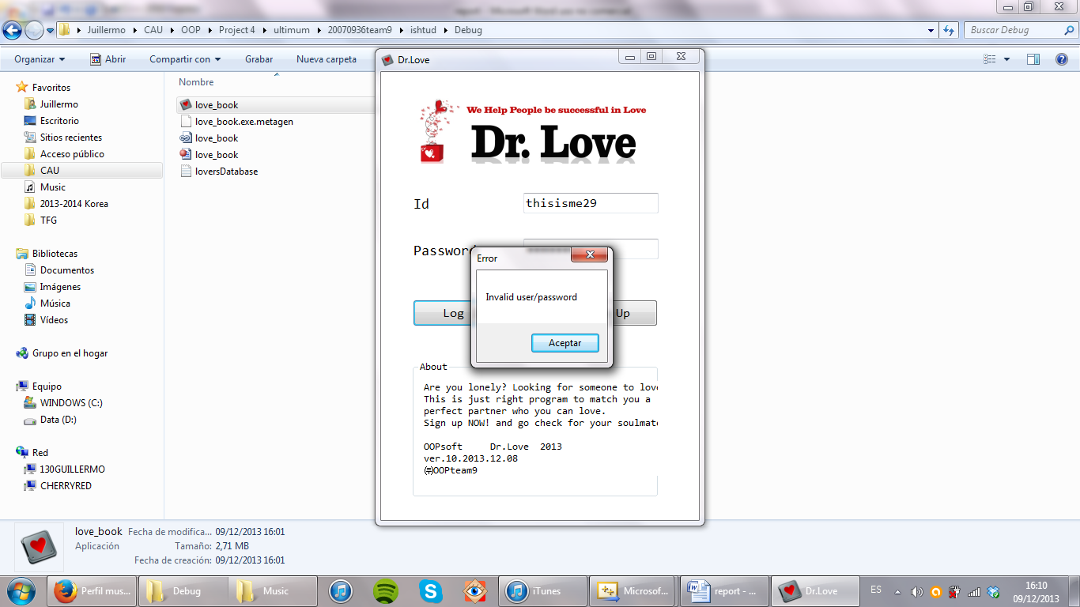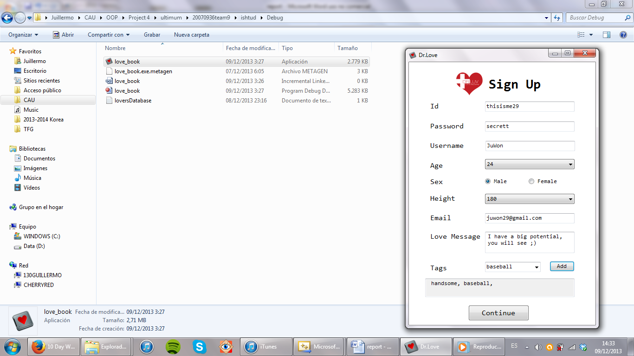

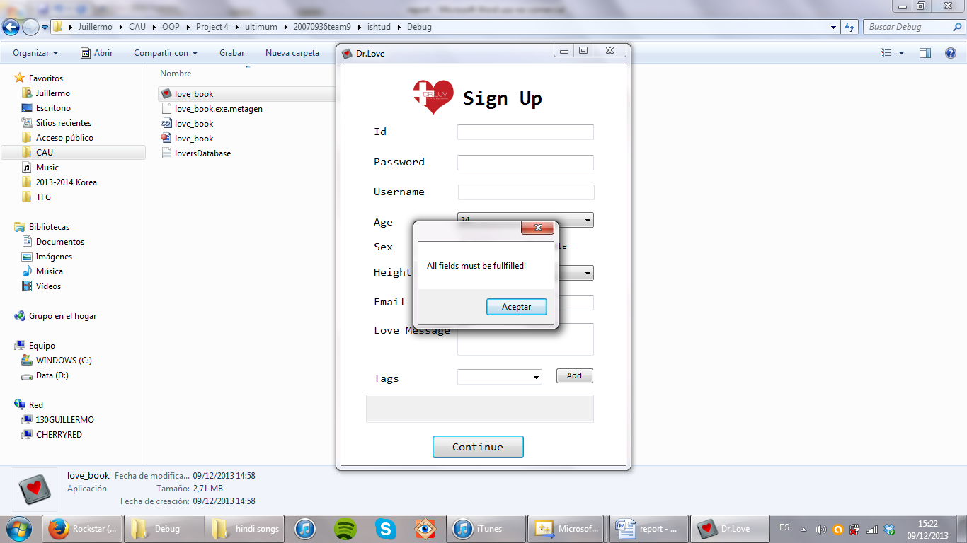

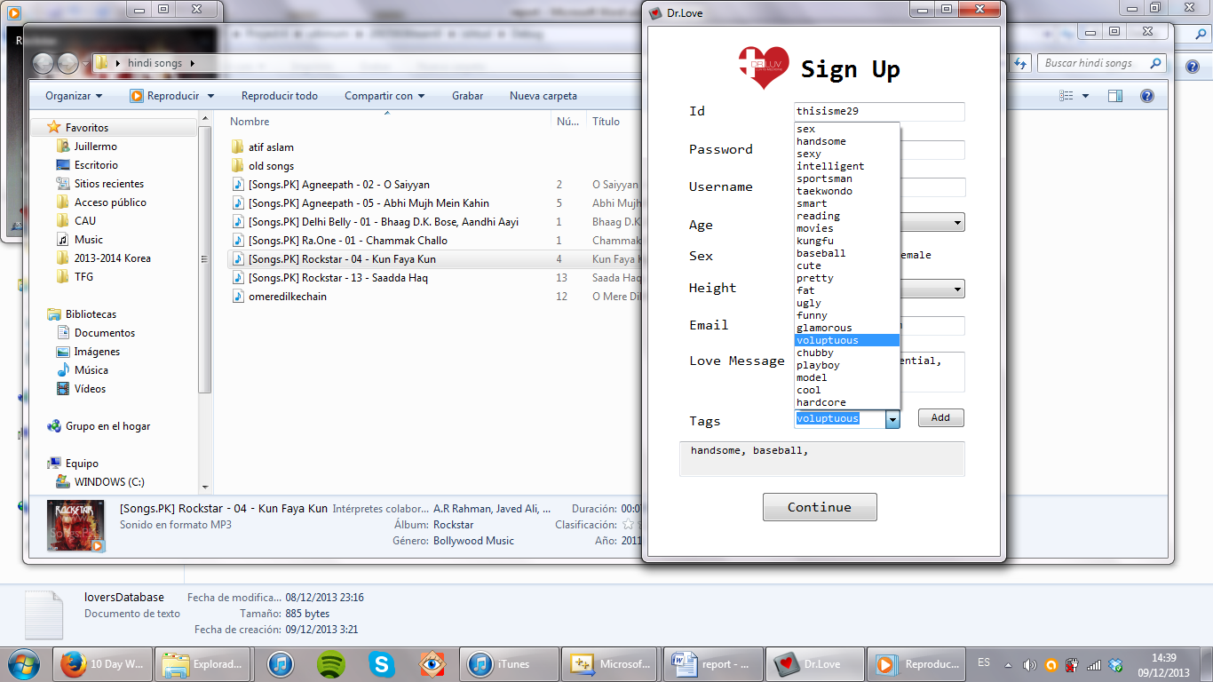

After this, the user is created and you can log in with it any time you want:

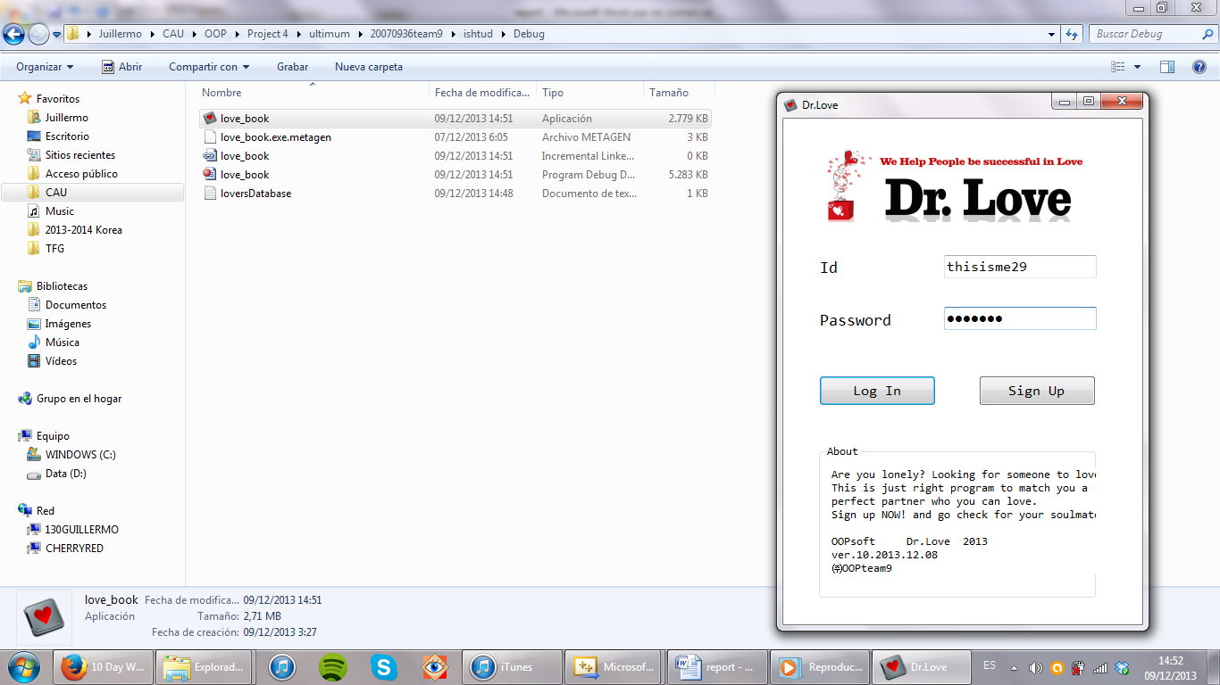

This time can also edit your information, except from ID and SEX.



After pressing CONTINUE either here or in the sign up form, you go to the searching page where you can input your preferences:



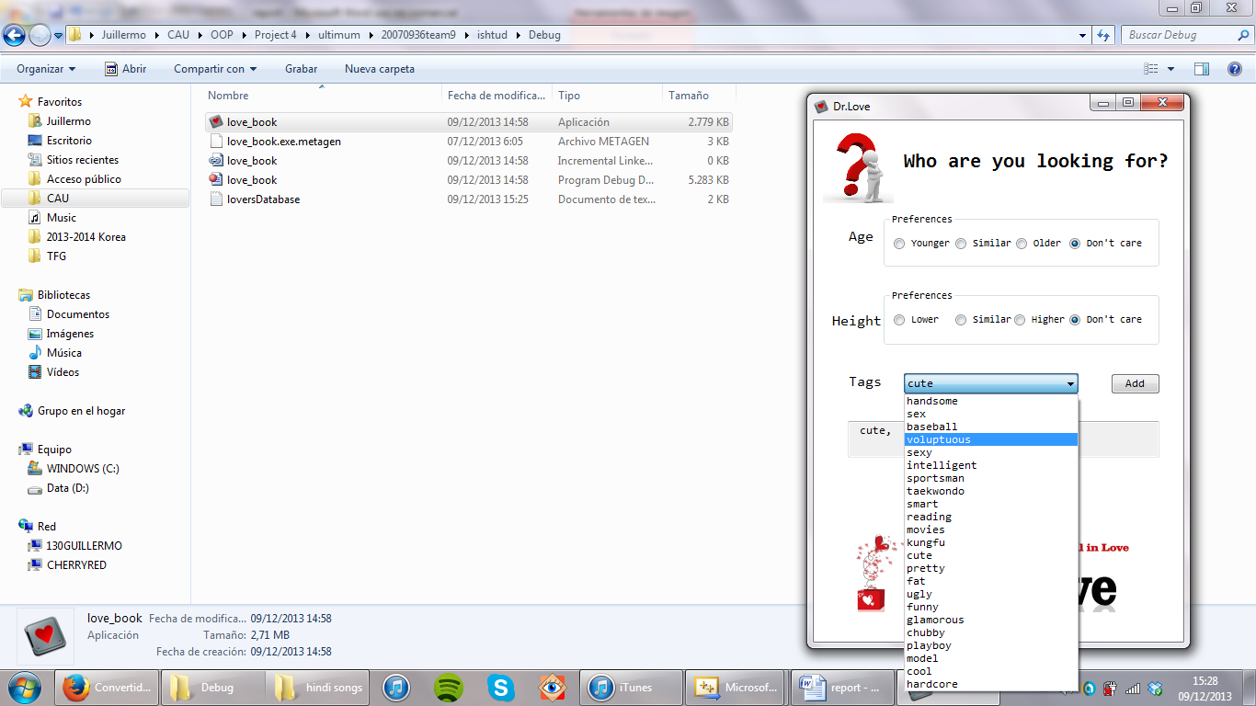

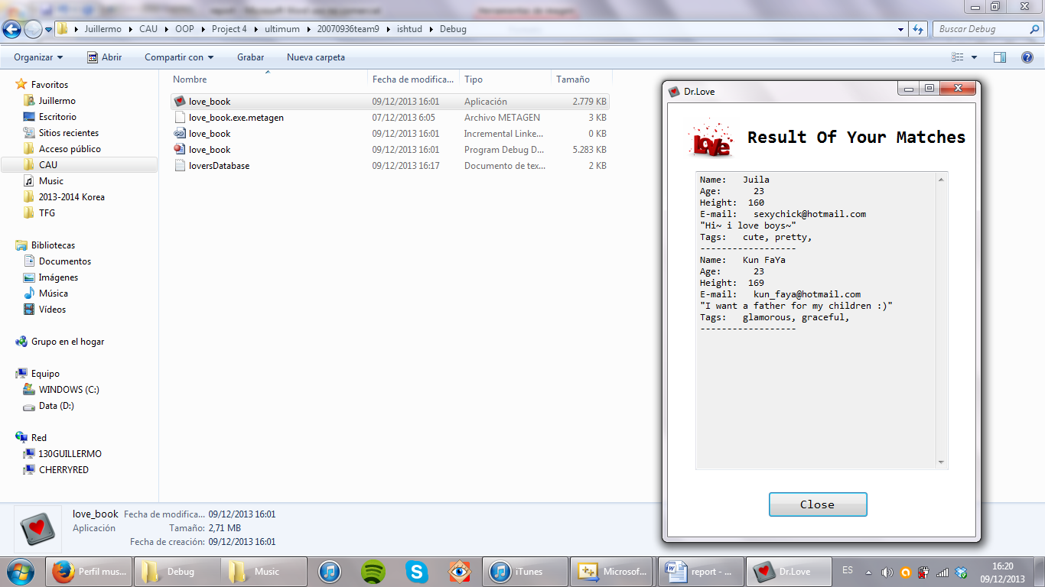

Finally, you press SEARCH and go to the results. You can notice that all the users displayed are from the other gender, they satisfy the preferences and the ones with the chosen tags are the first in appear.

After pressing CLOSE, the program closes.

**UML diagrams**

For our program we made three UML diagrams: class diagram, user-case diagram and activity diagram.

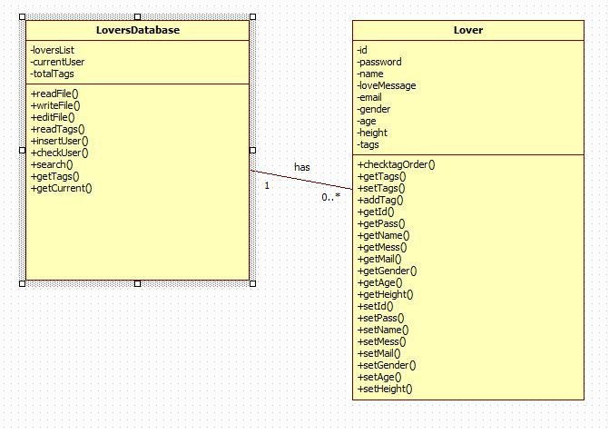

The **class diagram** contains the two classes we have designed and their relation (one database has from 0 to any number of users). Lover functions are mainly setters and getters and LoversDatabase contains the main functions of the program.

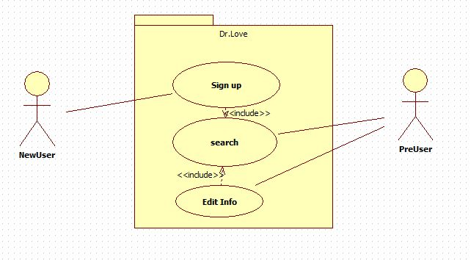

The **user-case diagrams** shows that a new user must sign up first for using the other options.

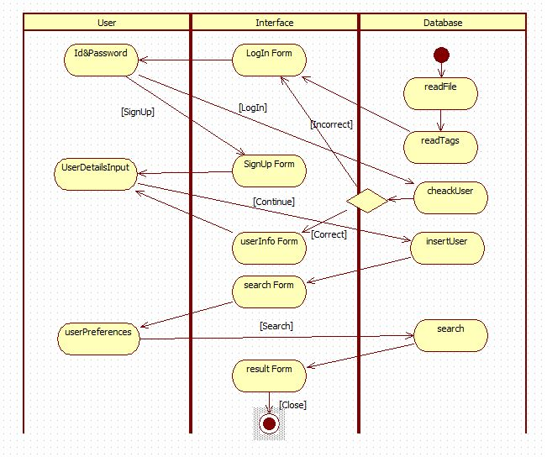

The activity diagram shows all the different interactions between the database, the interface and the user inputs. The activities in the user area represents data written by the user, while arrows coming from those activities represent the different buttons being pressed by the user.

**Applying OOP concepts to our program**

One of the first things we thought when we doing our program is the portability. We designed the database so it would be absolutely independent from the interface used for it: MSDOS, Windows Form or any other that accepts C++, so one of the features we gave to our program is its portability, reducing the dependability between the database and the interface.

We also designed easy interfaces for the classes LoversDatabase and Lover, so it the program is really easy to evolve using these blocks and to understand. The program is also prevented against users doing unexpected actions and easy to use. All the data is also well encapsulated, so it can only be accessed by the own class.

**Conclusion**

This project has been really satisfying in the sense that we have been able to create a whole thing from the very beginning just by ourselves. It has made us understand better how a real program is done and some of the issues that must be faced up and solved during the designing and implementation of the program. It has also shown us how important is a proper team working and communication, since a more complex program is impossible to be made only by one person. Team work and dividing tasks are essential for the project success.

After getting the current version we have felt really satisfied, since we worked hard in it, although we also realize that there is still a lot to be done and a lot of details and small improvements that can be added, which make us aware of how big the maintenance part can be.

And again, we have experienced the dance of the creation, the birth of such an abstract thing as a program is. Just thoughts, just logic, just algorithms, ones and ceros,… However, we go further and further in the creation of these abstract things, keep going more and more, increasing complexity and increasing power, until one day we reach the point, technological singularity, and the program complexity is not understandable for us anymore, and the program is the one who understands us, but it is ok, because that program is us, it is the future of the humanity and it is not as threatening as a child is for his father, they will live, we will die, but we will always want the best for our children, our programs, we will give them the world we have made so they can rule it.